Polaris Activation Process
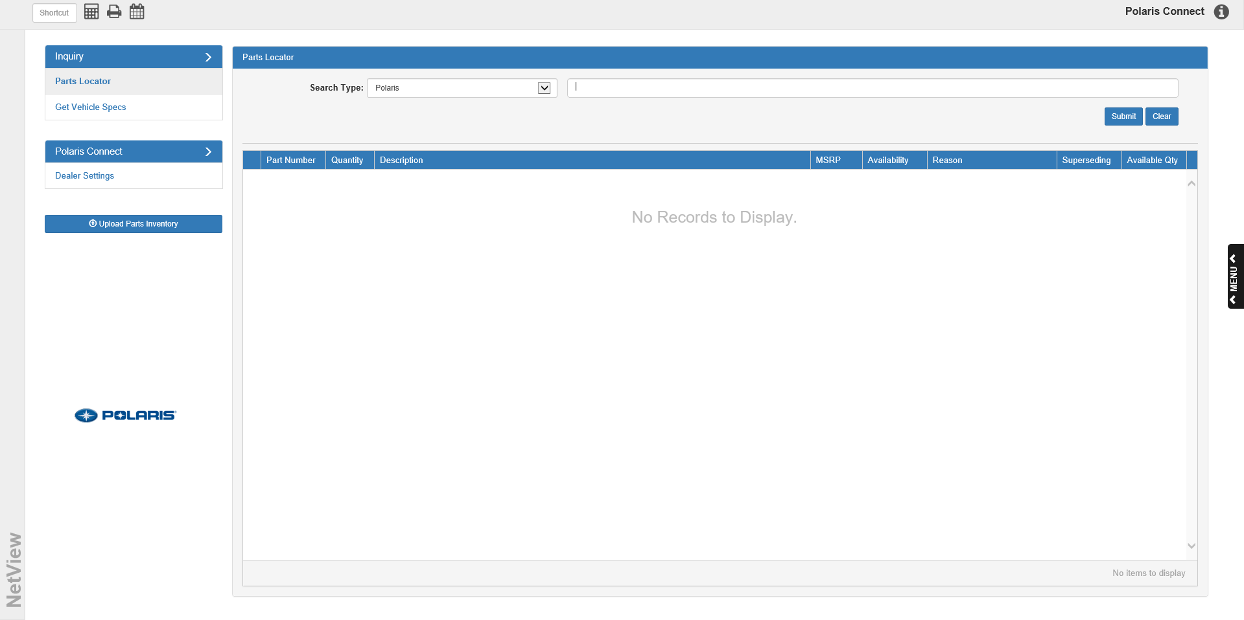
The first time you open Polaris Connect (POL) for your dealership, you will need to activate your credentials in order to use the program. To do so, you will need to open the Dealer Settings tab (see below for tab menu location).
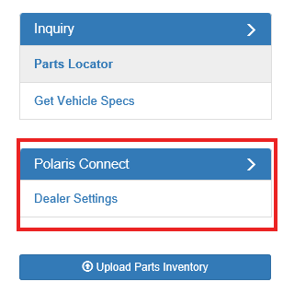

The following screen will appear:
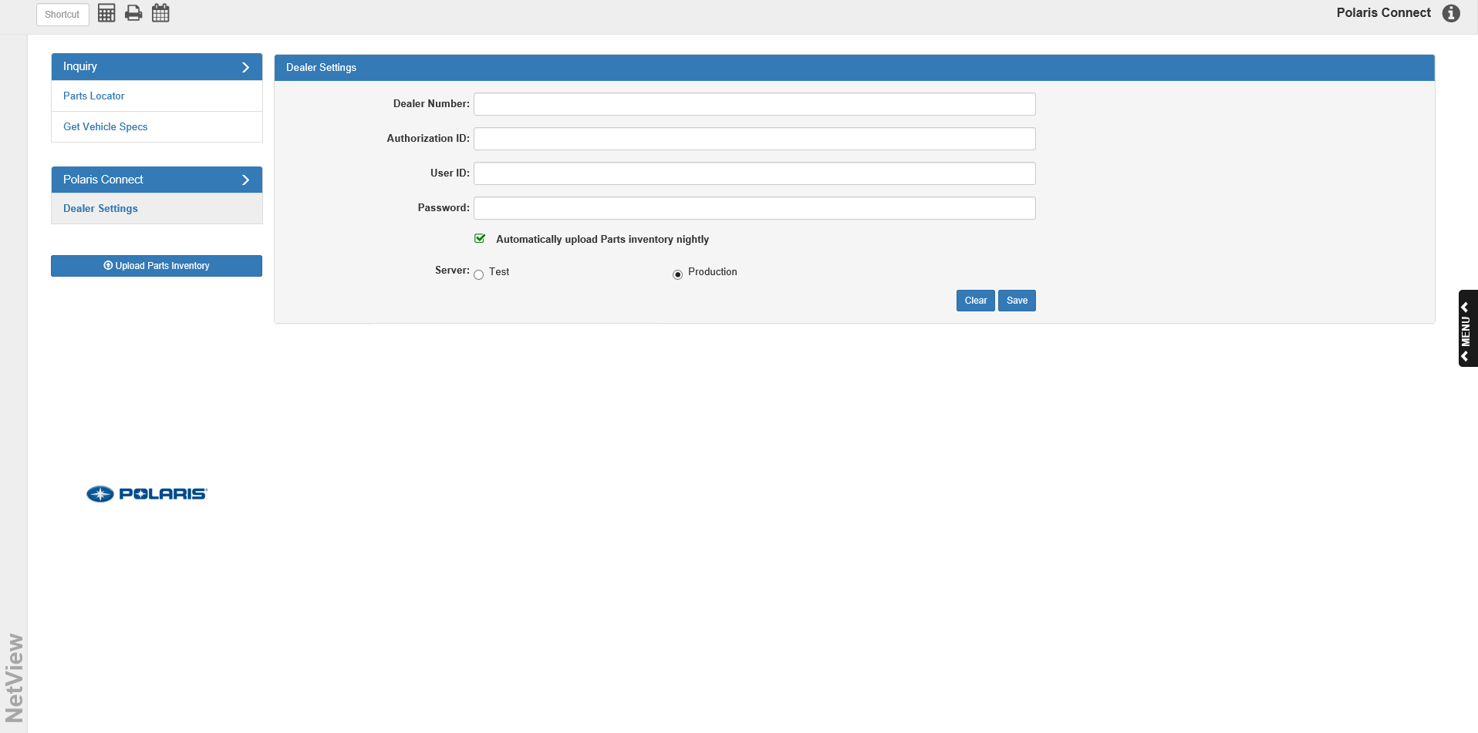
Enter the required information in these fields: your Polaris dealer number, your authorization ID for Polaris Connect, and your Polaris user ID and password. Make sure the Server is set to Production instead of Test, and that the checkbox labeled “Automatically upload Parts inventory nightly” is checked.

When you are ready click the Save button. The following window will appear:

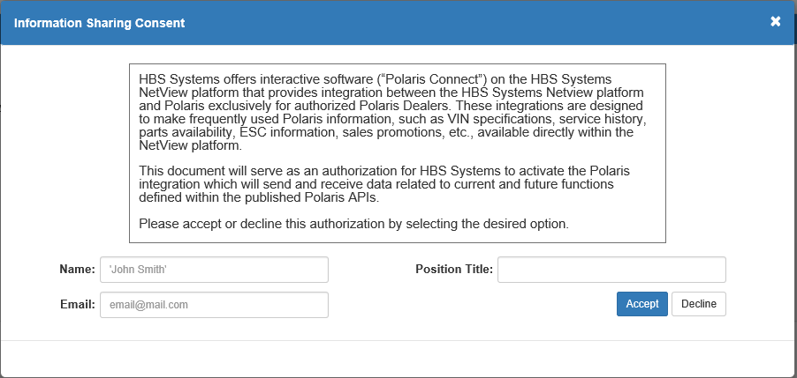



To finish activating the program, you must authorize HBS Systems to activate the program and consent to letting the program share information between your system and Polaris. Enter your name, your contact email address, and your position title at your dealership in the fields provided.

Click Accept to authorize the program. A copy of the authorization will then be sent to both your email and HBS Systems’ Support department. You will now be able to utilize Polaris Connect with your NetView system. Additionally, if you did not previously check “Automatically upload Parts inventory nightly,” accepting the contract will automatically check the box.

Note that this window will always appear when you click Save in the Dealer Settings tab, so you will be required to re-accept the contract every time you change your dealer information. Each time, the program will send a copy of the authorization to both your email and the HBS Support department, so both parties will always have an up-to-date version of the contract on file.

